From Believe … “As we read in Chapter 1, the first key belief in the Christian life begins with God. It is only logical that the first key practice in the Christian life is worshiping God. When we worship we are taking the revelation about the one true God-Father, Son and Holy Spirit-and reaffirming our belief that He is involved in our lives and wants to be in a relationship with us. As we do this, the amazing truths about God move from concepts in our heads to cries of our hearts. When we worship God for who He is and what He has done for us, it not only cements our confidence in God as we approach each day and each situation, but it also enables us to receive his love. When we receive God’s love in our hearts, we begin to see the world differently-as people made in God’s image.”

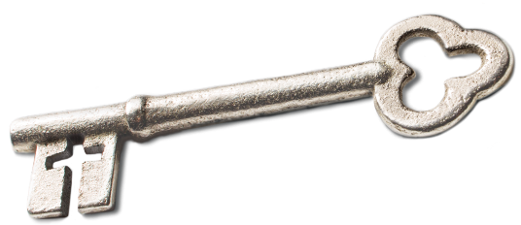
Sermon Notes
Worship
2 Samuel 6 (Psalm 95:1-2)
(Page 211 in the Pew Bible)

- Key Question
  - How do I __________ God in the way He ________?

- Key Idea
  - I worship God for _________ He ________ and _________ He has _________ for me

- What Should I Do?
  - Worship is about an __________ of __________

  - Worship is not __________; it is ______________

  - Worship is not just a __________; it is a __________

  - Worship is not simply a __________; it is a __________

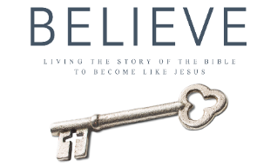
Each week of BELIEVE we ask you to read one chapter in preparation for the next Sunday. Please read Chapter 12 for Sunday May 27th.

