What’s in a name? Names are very important to us. They can be something of a family tradition passed on from each generation. Names can relay an importance about an event around the birth of a child. Names can also be used by playground bullies to tease and mock a person. How we treat people’s names are indication of how much respect them. Why? Because, names carry significance. It is no different with God. Today we will unpack the respect we are to have for God’s name.

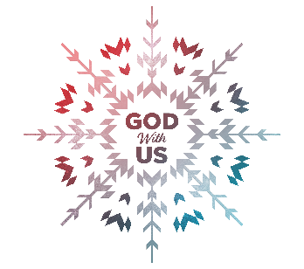
Sermon Notes
What’s in a Name?
Exodus 3:13-15(John 14:6)
(Page 40 in the Pew Bible)

- My __________ name is the name that _________ me from my _______

  - I Am – God always ________, He always ________, and always ________ ________

  - I Am Who I Am is to be known throughout the generations as __________ (He Who Is)

  - Sin ____________ me from a relationship with __________

- I can too easily ________ the ________ of God’s salvation

  - When I forget the weight of God’s salvation, I have a ____________ to use God’s name in a ________ way.

- My God _________ to make me _________

