As Americans, it is our privilege to live in the greatest nation this world has ever seen. As Christians, it is our privilege to worship in a land that is free. This nation, and our freedoms, have been provided for and protected by men and women throughout the ages who have sacrificed on our behalf. Today, we will honor those men and women who have served and continue to serve this great nation as We Remember.

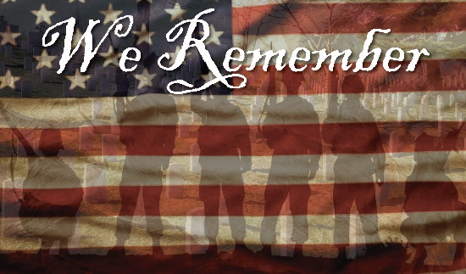
Sermon Notes
We Remember
Psalm 33:12-22
(Page 386 in the Pew Bible)

