Have you ever longed for a simpler time? Or perhaps you have found yourself on several occasions fondly looking back at the good ol’ days. Maybe that is something you will do this Christmas season. You will think back to those Christmas mornings as a child, all the wonder and magic of the season. Or maybe for you it is those moments watching your own children open their presents. As good as our past may be, in Jesus we have a hope in the days yet to come. This morning, as we go back to Bethlehem, we will recognize the value of looking back and the joy of looking forward.

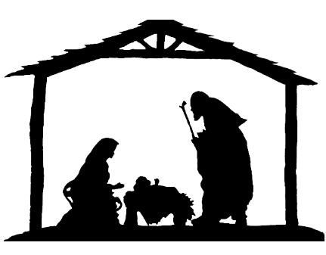
Sermon Notes
Water from the Well
1 Chronicles 11:15-19 (Micah 5:2)
(Page 284 In the Pew Bible)

- The water in Bethlehem transported David __________ to another __________

- The water in Bethlehem only __________ quenched thirst

- The water in Bethlehem was not _________ the _________

- Jesus’ water is a call to look __________

- Jesus’ water ______________ quenches our thirst

- Jesus’ water is ___________ the ___________

