Happy Father’s Day! Today is a day we honor our dad’s and say thank you for all the ways they have loved us, for the lessons they have taught us, and for the examples they have set for us. As we honor dad, it is a fantastic opportunity to remind ourselves that the kids in our lives are watching us, and as they watch us, they are learning from us. What lessons are you teaching the kids in your life?

Sermon Notes
Watching You
2 Chronicles 33 (Proverbs 22:6)
(Page 320 in the Pew Bible)

- Our kids are __________ us, and …

  - They see what we __________ want them to see

  - They see what we __________ want them to see

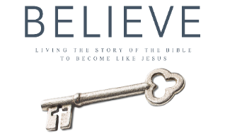
- I have a ____________ to set a good __________ and __________ for the kids in my life
Each week of BELIEVE we ask that you read one chapter in preparation for the next Sunday. Please read Chapter 15 for Sunday June 24th.

