Matthew 7:7-8

Sitting in the temple, Jesus watches as people come to give their offerings to God. Some, out of their wealth throw in large sums of money, hitting the metal and making all sorts of noise. In their midst is a widow with her last two coins. Her small offering is barely noticeable to the masses. But to Jesus, her offering was far grander than that of those who gave out of their wealth. Hers was an offering of faith and trust in God. Today, we will unpack this story, and look at the implications it holds for our lives.

Fields of Gold ~ Today we start our stewardship sermon series based off the book Fields of Gold. If you did not get a copy of this book last week, please pick one up off the coffee counter in the hub. Please read chapters 3 & 4 in preparation for next Sunday.

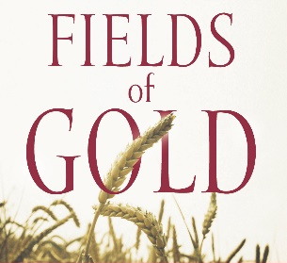
Sermon Notes
Trusting God Through the What Ifs
Mark 12:41-44
(Page 1017 in the Pew Bible)

- Am I _________the what ifs to _____________ my actions?

  - When the what ifs decide my actions, I am allowing ________ and _________ to take hold

  - When I let fear and anxiety take hold, I miss out on opportunities to _________ and _________

- Am I _________ my giving to teach me to ________ _________ and trust God?

- My giving should _________ me to a place in my faith journey where I have to trust God to _______________

  - As yourself … Do I have a ____________ moment of __________ in my faith journey?

