Happy Easter! We are excited you have chosen to celebrate Resurrection Sunday here with us at West Side. This day marks the moment in time when Christ defeated sin’s sting and death’s victory. We celebrate, because death is no longer something to fear. Today is Easter, and today we remember the promise of His life giving resurrection.

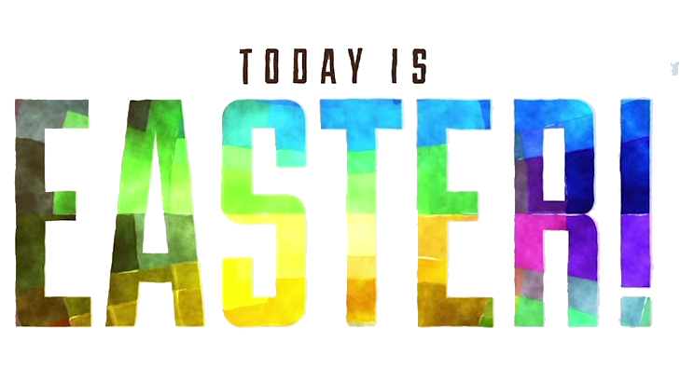

1 Corinthians 15:50-57 (Matthew 28:5-6)
(Page 802 in the Pew Bible)

- Today is more than a ____________ and more than another ______________

- Today is the day ________ lost its ________ and __________ lost its __________

- Today is the day the _______ ________ away

- Today is Easter – a celebration of ____________ through _______ Savior’s resurrection

