Luke 2:16-19
Nine months. That is the amount of time Mary has had to think and ponder. What did she know? What didn’t she know? She has information from the angelic visits to her, Joseph, Zechariah, and the shepherds. But more than that, the scriptures are full of information. This morning, we are going to look through the Old Testament at the information Mary had, and determine the type of hope she held in her arms.

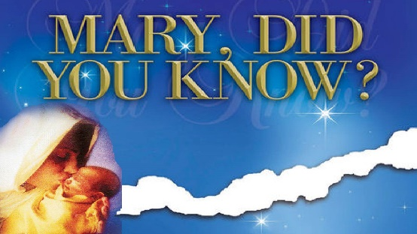
Sermon Notes
The Hope of Christmas
Genesis 3:15, Genesis 12:1-4, 2 Samuel 7:11-13, Isaiah 7:14, Isaiah 35:4-6

