From BELIEVE: “How do we know God? How do we understand and see the world we live in? How do we grasp where we came from and why we are here? How do we know where the story is ultimately heading? The answer is profound-God reveals Himself and His grand plan to us. Our role is to listen and believe. By simply looking at nature and the world around us we can conclude there is a God. But how do we learn about this God? How do we come into a full relationship with God? What are His plan and purposes for us? The answer to all of these questions is found in God’s revelation to us-the Bible.”

Sermon Notes
The Bible
2 Timothy 3:16-17(Isaiah 55:10-11)
(Page 833 in the Pew Bible)

- Key Question
  - How do I ___________ God and His _________ for my life?

- Key Idea
  - I believe the Bible is the ____________ Word of God that ________ my _______ and _________

- What Do I Believe?
  - God _________ to His People

  - God _________ through ____________

    - Scripture has __________

    - Scripture has __________

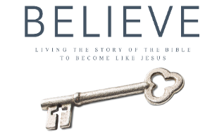
Each week of BELIEVE we ask you to read one chapter in preparation for the next Sunday. Please read Chapter 5 for Sunday March 19th.

