From BELIEVE … “We have learned how to see humanity the way God does-through eyes of love. Then we were challenged to treat people the way God does-with compassion. And now we declare that everything we are and everything we own belongs to God. The three beliefs are linked together. People devoted to thinking like Jesus believe they are to take the resources they are given, even their very lives, and use them [responsibly] to meet the needs of others.”

Open House ~ Butler Springs will host their annual Open House Sunday May 20th from 2:00 – 4:00 pm. This event provides an opportunity for you to bring anyone who would like to visit the camp. The camp will provide a meal as well as opportunities to experience a few of the camp activities. One big bonus, the entire event is FREE!

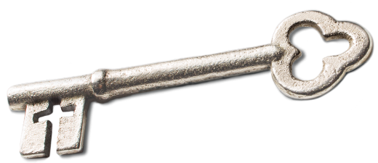
Sermon Notes
Stewardship
Genesis 1:26-30 (Psalm 24:1-2)
(Page 1 in the Pew Bible)
- Key Question
  - What is God’s __________ on my life?

- Key Idea
  - I believe everything I __________ and everything I __________ belong to God

- What do I Believe?
  - I am __________ and I am created in God’s image and should __________ the earth
    - ________ is the Hebrew word __________, which means tread upon, subdue, rule over
    - Mankind is __________ to all other life forms

  - Mankind was created to __________ the earth because the earth was created to be _____________

  - Mankind was created to __________ the earth and bring it under __________
    - I am to do so with great __________
    - God intended for us to __________ all the _______________ of the earth
    - This is not a license to __________ the earth, but a charge to do so with __________

  - I am _______________ to the Creator for the way I __________ His creation

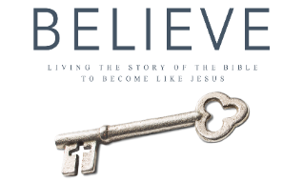
Each week of BELIEVE we ask you to read one chapter in preparation for the next Sunday. Please read Chapter 10 for Sunday May 6th.

