Matthew 6:25 & 31-33
“Whoever sows sparingly will also reap sparingly, and whoever sows generously will also reap generously.” (2 Corinthians 9:6 NIV). It is clear, that in these words of Paul, he does say that those who are generous will receive something back in return. But what is that something that comes to us in return? Is it more financial wealth? Is it spiritual blessings? Is it the growth of the kingdom? Today, we will unpack these words, and seek to understand Paul’s full intentions.

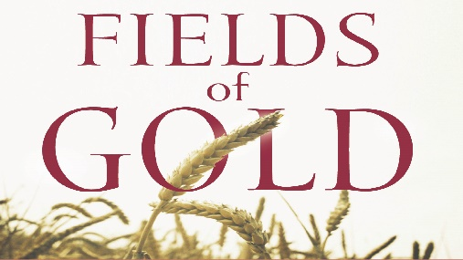
Sermon Notes
Sowing for the Harvest
2 Corinthians 9:6-11
(Page 1162 in the Pew Bible)

- The ____________ of my generosity directly impact the ____________ of my reward

  - This is not a get rich quick __________ nor is it about _______________ wealth

  - There is a clear _______________ between the __________ of the giver and the ____________ gift

- Financial giving __________ my life with God’s __________

  - It forces me to see the __________ that God sees

  - It forces me to ____________ God in the ______________ of my financial decisions

- God ____________ those who ____________ His agenda

