Laminations 3:22-24
Welcome to 2020! Not only are we starting a new year, we are also starting a new decade. For many of us we view a new year as a new beginning and an opportunity to examine our lives and determine some things we would like to change. Maybe we want to be a kinder person. Perhaps we want to lose some weight. Maybe we want to get our finances in order. For many of us, our goals are noble, but many times we fail. Why is this? Many times we fail because our process is too big. Today, we will examine why the small things give us the most potential for a big difference.

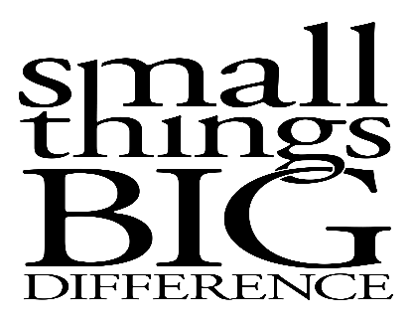
Sermon Notes
My One Word
Zechariah 4
(Page 950 in the Pew Bible)

- Defining _________ word for 2020 allows me to make a big ______________ for this new year

- How to define my one word …
  - I have to ____________ see to begin

  - I have to ask _______________ to see ___________

  - I have to focus on the __________ things and not get lost in the _________ things to have _________

- Once I see clearly, I can define my one word …
  - My One Word for 2020: _______________________

