From BELIEVE … “We believe the one true God has unfolded His grand plan to provide salvation through Jesus Christ. We believe God loves all people and extends an invitation to everyone to receive eternal life. We believe there is a heaven and a hell and that Jesus is returning to judge the earth and establish His eternal kingdom. Only those who receive salvation by faith in Christ in this life will be a part of the eternal life to come. We believe God has purposed the church to be the primary ambassador to spread this message, this good news to the world. Because of these values we commit ourselves to sharing our faith.”

Sermon Notes
Sharing My Faith
Acts 8:26-40 (Ephesians 6:19-20)
(Page 764 in the Pew Bible)

Key Question
- How do I share my __________ with those who don’t _________ God?

Key Idea
- I share my ________ with others to fulfill God’s _________

What Should I Do?
- I must realize that ____________ my _________ is the first way to share my __________

- I must realize, at some point, I have to __________ my __________

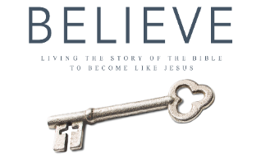
Each week of BELIEVE we ask that you read one chapter in preparation for the next Sunday. Please read Chapter 21 for next Sunday August 12th.

