From BELIEVE … “Self-control refers to the ability to control one’s emotions and behavior. Everyone at some point struggles with self-control-it’s the presence of the sin nature within us. So how does God help us when we’ve lost control and let our sinful nature take over? How does He free us from addictions and sinful habits? God’s Word contains the answer.”

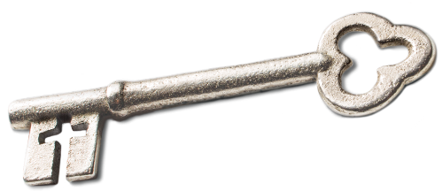
Sermon Notes
Self-Control
Joshua 6:15-19, 7:1-5, & 7:20-21
(Titus 2:11-13)
(Page 150 in the Pew Bible)

Key Question
- How does God free me from ____________ and __________ habits?

Key Idea
- I have the __________ through Christ to __________ myself

Who am I Becoming?
- I am ____________ a Christian ____________ by self-control
- Defining self-control
  - Self-control is the Greek word ____________
  - __________ is a combination of two Greek words … _________ and __________
    - _____ means from ________, or something _________ from inside
    - __________ implies ____________, strength, _________
  - Our working definition of ____________ is the _________ from _________ to control what I do or do not do
- When I __________ self-control, I __________ three different groups …
  - __________
  - The ____________ I love
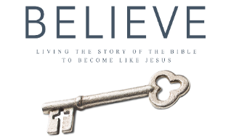
  - The ____________ I am __________ with
We will take a one week break from our BELIEVE series for our Founder’s Day Celebration. This is a great opportunity to catch up on your reading.

