There is something magical about being a kid. The worries of our world, the struggles of adulthood, and the endless decisions that need to be made are absent in the mind of a child. Children are pure. Children are humble. Children need help. It’s such a wonderful part of the human experience. And Jesus, He calls us to be like children. He tells us, that to be a part of His kingdom, we need to have childlike faith. Today, as we begin a new sermon series that will take us through the summer titled, Faith Like a Child, we will discover what it means to have childlike faith.

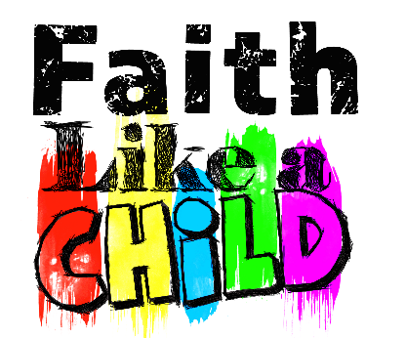
Sermon Notes
Praise Him, Praise Him All Ye Little Children
Mark 10:13-16 (Matthew 18:2-5)
(Page 1013 in the Pew Bible)

Citizenship in the Kingdom of Heaven …
- … requires ____________ because children are _________

- … requires that we do not seek __________ or __________ because children do not

  - Children don’t _____________ their smallness

  - Children __________ their parents

  - Children seek to __________ the adults in their life

  - Children love ______________ and _________ easily

Following is the link to the blog the above thoughts are developed from … http://joypursued.com/children-teach-being-humble/

- … requires that we ______________ our need for __________ as children so __________ do

