From BELIEVE: “The God of the Bible is the only true God-Father, Son, and Holy Spirit. He is the one all-powerful, all-knowing eternal God. But is He good? Is He involved in His creation? Does He love us? Does He have a plan for us? Is He interceding and intervening to move the events of our life and world toward His intended purpose?” Today we will consider these questions as we get to know our Personal God.

Sermon Notes
Personal God
Psalm 139 (Psalm 121:1-2)
(Page 433 in the Pew Bible)

- Key Question
  - Does God ________ about ________?

- Key Idea
  - I believe God is __________ in and cares about my ________ life

- What do I believe?
  - God is ________

  - God has a _________

  - God cares for _________

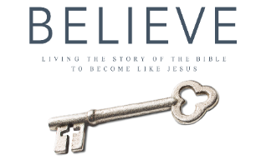
Each week of BELIEVE we will ask you to read 1 chapter in preparation for the next Sunday. Please read Chapter 3 for Sunday March 4th.

