The Apostle Paul is well known for his communication style of writing letters to various churches and individuals. He would write these letters to correct bad doctrine, to encourage congregations, to continue his teaching, and to let those he loved know that he was thinking of them. Today, we begin a four week look at one of Paul’s letters that he wrote to the church in Colossi. The letter begins with Paul telling the church what about them makes him thankful.

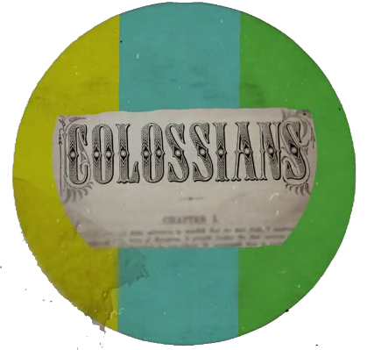

Sermon Notes
Paul’s Thanksgiving
Colossians 1:3-8 (Psalm 100)
(Page 821 in the Pew Bible)

- Would the Apostle Paul be thankful for …
  - Our _________ in Christ?

  - Our _________ for one ___________?

  - Our passion to ________ and ________ people to Jesus?

  - Our ________ in the __________ and our response to ____________ fruit?

