We conclude our walk through the book of Colossians this morning looking at the most important teaching of Paul; in Christ, we are raised anew. No longer are we defined by our sins, because they have been hidden with Christ in the grave. Now, God looks at us and sees His Son. This one simple yet profound difference changes everything. This morning we will celebrate who we are in Christ Jesus.

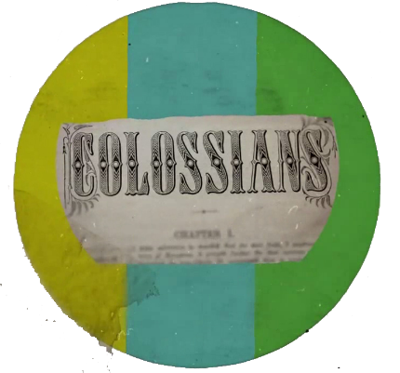

Sermon Notes
Paul’s New Self
Colossians 3:1-4 (Psalm 63:1)
(Page 822 in the Pew Bible)

- Paul teaches that in _______ we have been raised ________ - Colossians 3:1-4

  - I don’t have to be ________ on the __________

  - I get to ___________ on the ___________

- Paul teaches that a __________ action, ___________, should be given to our ________ - Colossians 3:9-11

- Paul teaches that in Christ a _______ ________ is put on – Colossians 3:9-11

  - Faith that does not _________ me, is an ___________ faith

- Paul teaches that in Christ we now ___________ God’s __________ people – Colossians 3:12-14

  - My life must ___________ who I _________ to

