The Apostle Paul was a teacher of the law, a Pharisee. He liked rules and regulations. He liked dotting his “i’s” and crossing his “t’s.” But in Jesus, he found a new freedom … a freedom known as grace. Now, as he writes to his friends in Colossi, he sees that they are being led astray by a bunch of added layers. Paul reminds them that in Jesus they have real freedom.

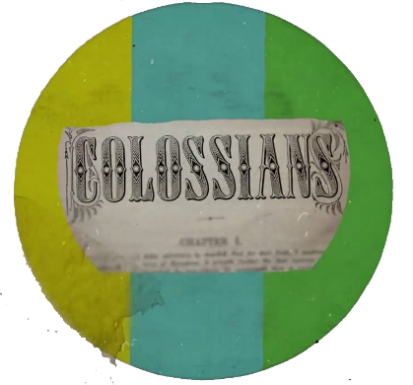
Sermon Notes
Paul’s Freedom
Colossians 2:6-19 (Psalm 47:1-2)
(Page 822 in the Pew Bible)

- Paul recognizes that ___________ only comes through Jesus – Col. 2:6-7

- Paul recognizes that false teachers are ___________ ___________ to Jesus

  - They added additional _____________ - Col. 2:8

  - They added a _______ of the ________ - Col. 2:8-10

  - They added ____________ to the ____________ for salvation – Col. 2:11-15

  - They added ascetic ________ and ___________ - Col. 2:16-17
    - Ascetic - ________ ________-__________

  - They added ________ of the ________ - Col. 2:18

- Paul’s freedom comes because Christ ________ _________ - Col. 2:19

Outline develop from William Barclay work The Daily Study Bible

