In our country’s brief existence, we have quickly risen to become one of the greatest nations in our world’s history. Our nations greatness, and our freedoms, are not an accident. Men and women of faith laid a foundation upon which America was built. Today, collectively, we seem to be moving away from that foundation, to what seems to be the detriment of our nation. However, a simple return to our founder’s principles has the potential to restore our greatness. Today we will explore what those principles were and how they can be our anthem in this age.

Sermon Notes
Our Anthem
Lamentations (Palm 33:12)
(Page 568 in the Pew Bible)

What made America great among nations?
- __________ … our ______________ with God

- __________ … that all mankind __________ inalienable rights given by God

- __________ … that God __________ lead if we ________ follow

What will continue to make America great among nations?
- _________ … remembering that we must continue to __________ with God

- __________ … remembering that we have ____________ rights as people

- __________ … remembering that God ________ lead if we ________ only follow Him

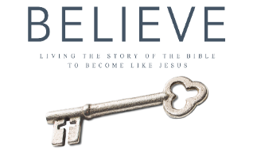
Each week of BELIEVE we ask that you read one chapter in preparation for the next Sunday. Please read Chapter 16 for Sunday July 8th.

