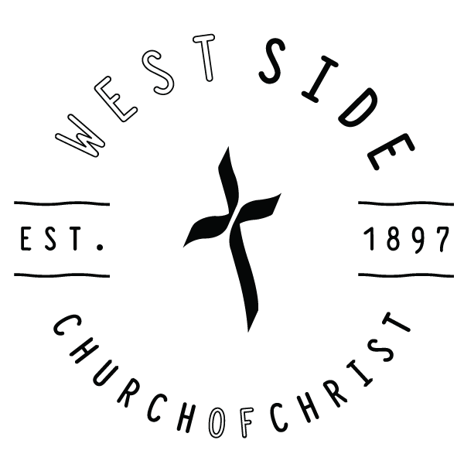
July 24, 2022 - Sermon Notes
West Side Church of Christ Staff
625 Hart Rd., Lebanon, Ohio 45036 Michael Dawson, Senior Minister – medawson03@gmail.com
p: 513-932-3045 | Office Hours: M-F 9-3 P.M. Marty Egelston, Minister – marty.egelston@gmail.com
Service Times Emily Bosdell, Children’s Minister – bosdellem1@gmail.com
Sunday Morning Worship at 10:00 A.M. Cheryl Fox, Office Administrator – Cheryl.fox2424@gmail.com
Sunday School for all Ages to resume in 2022
Youth Group Sunday’s at 5:30 P.M.
Wednesday Night Bible Study 6:30 P.M. | Worship Team Practice 7:00 P.M.
Thursday Online Bible Study 7:00 PM

wscoconline.org Your online home for news, prayer requests, sermons, and more!
Facebook.com/WestSideCoC A place to stay up to date and share with your friends

https://www.youtube.com/c/WscoconlineOrg Our online video home

What We Believe
The West Side Church of Christ exists to love and lead people to a life changing relationship with Jesus Christ. We place our complete faith and trust in Jesus Christ. We believe Jesus was born of a virgin, died for our sins in an expression of God’s love, and rose from the grave. We believe the Bible is the inspired Word of God, and it has authority over our lives. We hold on to no human creed and have no church government beyond our local elders. We have no creed but Christ and no book but the Bible. We teach the divine plan for salvation: Faith (Mk. 16:16), Repentance (Acts 2:38), Confession (Matt. 10:32,33), Believers Immersion (Gal. 3:27), and Holy Living (1 Cor. 6:11). Finally, we believe we are Christians only, not the only Christians.
Dear parents, we encourage you to take advantage of our children’s ministry opportunities for your kids. We offer age-specific opportunities from birth through 5th grade during our service to help your children grow in their relationship with Jesus Christ. If you are interested, one of our greeters can direct you to our children’s locations.
CONNECT WITH US
FOR OUR KIDS
WELCOME
Welcome! We are so glad you have chosen to worship with us today. We hope your experience with us will be warm and relaxing.

Be Careful
Ephesians 5:1-15
(Page 1176 in the Pew Bible)

Why the Warnings?
Because God is ______________!
- ______________
- ______________

- Be careful ____________ __________ ____________ (Ephesians 5:15)
- Be careful ____________ __________ ____________ (Ephesians 5:3)
- Be careful __________ __________ __________ (Philippians 1:3-11)
  - See the ______________ of the past (Vs. 3 – 6)
  - See the ______________ of the present (Vs. 7-8)
  - See the ______________ of the future (Vs. 9-11)

Conclusion
So be careful ______________ eyes and ____________ eyes what you __________, __________, __________ and __________.
West Side News and Notes

West Side Connection Cards ~ In the cardholders in the pews are connection cards. If you are a first-time guest or a returning guest, please take time to fill out this card so we can get to know you better. Please put them in the Giving Box just outside the Sanctuary. Also, if anyone has a prayer concern, please write those on the back of the card and put in the Giving Box as well.

Thank You! ~ Brian Poston, Jillian Philippo and Max Newlon want to thank everyone for the wonderful Graduation Celebration. A special “Thank You” to Bobbie Vires for coordinating and getting everything set up.

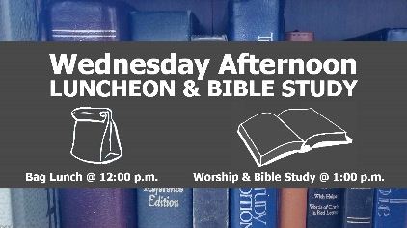
Wednesday Afternoon Luncheon and Bible Study ~ Join us on Wednesday afternoons for lunch and Bible study. Bring a sack lunch at 12:00 followed by worship and Bible Study at 1:00.

Wednesday Night Bible Study ~ Join us on Wednesday evening at 6:30 p.m. for an Adult Bible study.

New Bible Study for Junior High Girls ~ Every other Wednesday from 6:30-7:30 PM will be a Bible study for Junior High girls (6th – 8th grade) led by Staci Crawford and Maddie Bosdell.

Children’s Class on Wednesdays ~ Wednesday evenings at 6:30 PM will be a class for our children, Pre-K through 5th grade. Come join our Adult Bible Study and bring your kids.

Thursday Online Bible Study ~ Join us for Bible Study from the comfort of your home. We are currently looking at the book of Colossians. See Cheryl Fox for more details.

The Chosen ~ Starting in September, a Bible Study based on the popular show The Chosen will start. We will start Monday evening, September 12, 6:30 PM, here at the church. If you would like to participate there is a sign-up sheet in the HUB.

Parents Night Out ~ This week’s PNO is Tuesday July 26th from 6 – 8 PM. Wear your water gear and get ready to get wet! Let Emily Bosdell know if you are going to be there for supper!

WSKids Field Trip ~ All kids that are able, we are going to Optimized Senior Living Center, 150 Rough Way, Lebanon on Thursday, July 28th at 2 PM to sing Happy Birthday and then to go for ice cream!

JoyBelles News ~ Reminder that the Birthday Celebration at the Optimized Senior Living Center is this Thursday, July 28th. Meet at the church at 1:30 PM. There is a sign-up sheet in the HUB to sign up for ice cream and cupcakes for the next few months. For more information on this, please see Melodee Ashby, Charlotte Peek, or Jan Hollingsworth.

Congratulations Keith Warner ~ After 34 years as Director of Butler Springs Christian Camp, Keith Warner will be retiring on Sunday July 31st. That Sunday will be an open house, from 2:00 - 6:00 PM at the camp. All West Side Christians are invited to attend this event to celebrate Keith's ministry and the impact he has made on countless lives.

Ladies Lunch Bunch – Join other West Side Ladies Friday, August 5th at noon at Frisch’s in Lebanon for food, fellowship, and fun.

Matthew 25 Ministries – Saturday, August 6th from 9 AM – 11 AM is West Side’s time to volunteer at Matthew 25 Ministries. Talk to Laura Williams for information.

All Church Canoe Outing ~ Sunday, August 14th will be our annual canoe trip @ 1 PM through Morgan’s Canoe, 5701 OH-350, Oregonia, OH. It is a 6-Mile Lower River Trip: Fort Ancient to Morrow. You must make reservations, choosing a kayak or canoe, and there are group rates for canoes at a discounted priced. Enter West Side Church of Christ. Must be 4 years or older.

Prayers for College Students ~ We are looking for College Prayer Pals for the upcoming school year. We have several students who will be attending college this Fall and could use extra prayers from their church members. This is a great ministry to our young people and a great way to build relationships and encourage them. You can sign up and pray only if that is what you are able to do, or you can send cards, texts, treats or gift cards. Whatever you can do is a blessing to them. Please contact Kristy Meilstrup to be matched up with a college student this year!

Address for JoAn Brown – JoAn Brown is recovering from a stroke at her son’s home. If you want to send a card, 4310 Gardnersville Road, Crittenden, KY 41030.

FINANICAL PEACE UNIVERSITY ~ Never worry about money again with Financial Peace University! It’s the proven plan to help you master budgeting, beat debt, and live the life of your dreams. Through nine lessons rooted in biblical wisdom, you’ll learn from Dave Ramsey and his team of financial experts. And now, you can try Financial Peace free for 14 days! Visit fpu.com/1152076 to sign up and learn more. Class starts Sunday, September 11, 2022, at 6:00 PM. See Cheryl Fox for more details.

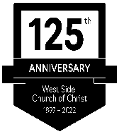
West Side 125th Anniversary News
In 1962 a group from the Cherry Street Church began a new work meeting in a private home, then the Grange Hall, and finally to the location where the church presently stands. The new congregation, called the West Side Church of Christ, continued to grow as did the Lebanon Church of Christ. In 1991 the two churches came back together as one congregation. The 125th Celebration will be Sunday, September 25, 2022. Logo by Lauren Meilstrup.

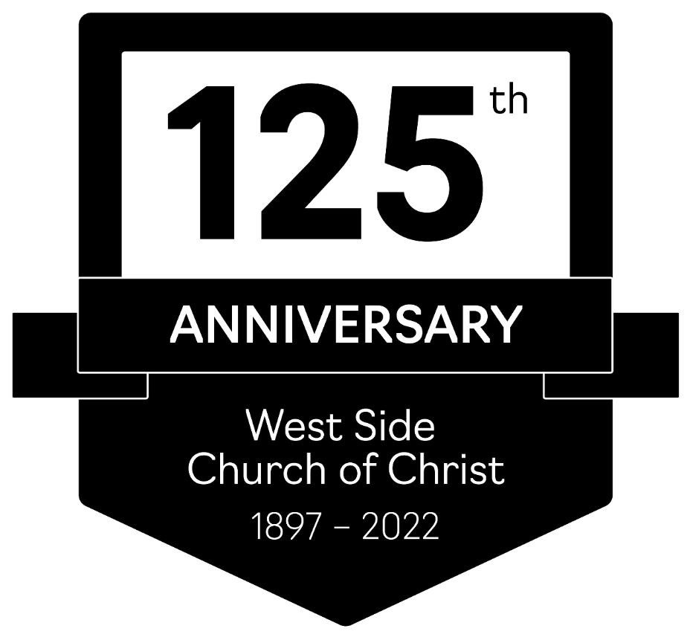

Daily Bible Reading
07/24 | 07/25 | 07/26 |  | 07/27 | 07/28 | 07/29 | 07/30
Ecclesiastes 12,  Song of Solomon 1-4 | Song of Solomon  5-7 | Song of Solomon 8,  Isaiah 1-2 |  | Isaiah  3-5 | Isaiah  6-8 | Isaiah  9-11 | Isaiah  12-14
Financial Report
General Fund |  |  |  |  | Building &  Capital Improvements Fund
Weekly Budget Need |  |  | $4,315.84 |  | Previous Week Offering  $0.00
Previous Week Offering |  |  | $8,400.00
Year to Date Offering |  |  | $181,485.30 |  | Building Fund Balance  $21,326.14
Year to Date Budget |  |  | $125,159.36

