We are living in an unprecedented time in American history. In thirty-seven days, American’s will go to the polls to elect the next President of the United States. This election process has been unlike any seen before. How should we as Christians respond? What is the relationship between our faith and our politics? Today we start a new series titled One Nation Under God as we explore the relationship between faith and politics and remind ourselves that God is still in control.

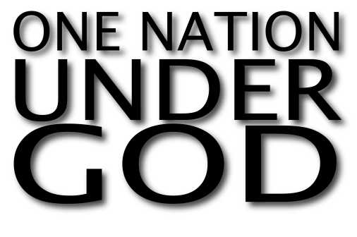
Sermon Notes
One Nation Under God
Psalm 33:12-22 (Luke 9:23-24)
(Page 386 in the Pew Bible)

- America had a ______________ beginning

- Ancient Israel had a _____________ beginning

- To both nations, ________ of ________ set in

- We must remember, in the ________ of ________, God is ________ in control.

