From BELIEVE … “We believe to become. The ten key beliefs of the Christian life are not an end in themselves. They are to be understood in our minds (a renewal from the fall) and then accepted in our hearts by engaging in the ten spiritual practices. We are now moving to the ten key virtues of the Christian life. As the beliefs are embraced and owned in our hearts, the fruit of the Spirit appear on the external branches of our lives for others to see and taste. The ultimate fruit, the most important expression of being like Jesus is LOVE. What does it mean to sacrificially and unconditionally love and forgive others?”

Sermon Notes
Love
1 Corinthians 13 (1 John 4:10-12)
(Page 800 in the Pew Bible)

Key Question
- What does it mean to _______________, and _______________ love others?

Key Idea
- I am ____________ to loving God and loving others

Who Am I Becoming?
- My love is an ________________ of who I am becoming

- My love is ____________ to anything else I become

- My love must be __________ love

  - _________ love is the kind of love Jesus _______________ on the cross

  - The attributes of _________ love are negative … _______-denying, ________-emptying

- My love must ________ to the top and _________

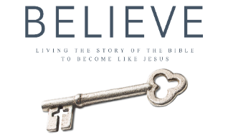
Each week of BELIEVE we ask that you read one chapter in preparation for the next Sunday. Please read Chapter 22 for next Sunday August 19th.

