Was the Ark big enough to really hold all the animals living at the time? Why don’t many Christians believe in evolution, after all isn’t it settled science? These two questions, plus many others are often presented to us as followers of Jesus. Why? Because there is a great divide in America today when it comes to the creation account found in the Bible and the teaching of evolution. So how do we respond? We respond by taking this hot potato and by developing an apologetic response as we share our faith.

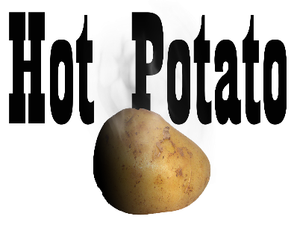
Sermon Notes
Is Noah’s Flood the Missing Link?
Genesis 6-8 (Psalm 85:10-13)
(Page 4 in the Pew Bible)

- Noah’s flood was a ___________ of the earth
  - The ark was a vehicle of ____________
  - The ark was _________ enough for all the _______
  - The ark was ___________ than needed to provide room for __________

- Noah’s flood was a ___________ event and explains the _____________ record

- Noah’s flood supports _______evolution but not ________evolution
  - ________evolution is the changes we see within a species of animals
  - ________evolution is the change of one species to another species

- Noah’s flood and ark provide us a glimpse of God’s __________ through __________

