Watching an artist at work can be a breath-taking experiencing. Watching a blank canvas transform into a beautiful painting can simply be awe inspiring. Watching a potter form a lump of clay into a piece of decorative pottery can be mesmerizing. Isaiah calls God the potter and us the clay. What work is the Potter creating in you? What masterpiece is He forming in you?

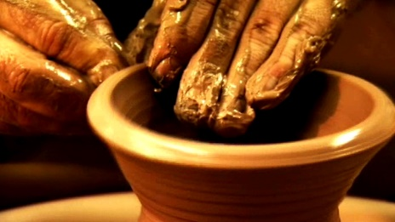
Sermon Notes
In the Potters Hands
Isaiah 64:8-12 (Ephesians 2:8-10)
(Page 519 In the Pew Bible)

- God is the _________ … I am the ________

- Am I ________ to let God _______ and ________ me?

  - What is the ____________ of my heart?

  - Where am I at in my ___________ __________?

- I get to ________ with God as He crafts new ________

