From BELIEVE: “When we open the pages of the Bible, God’s trusted revelation to us, we discover that the one true God-Father Son and Holy Spirit-is involved in and cares about our daily lives. We also learn that He has provided the way for us to come into a personal relationship with Him through faith in Jesus Christ. When we believe and receive this gift of grace, we become a new person with a new identity and a new outlook on life. Our worth is no longer defined by what we do, but by who we know. We are significant because we are children of God.”

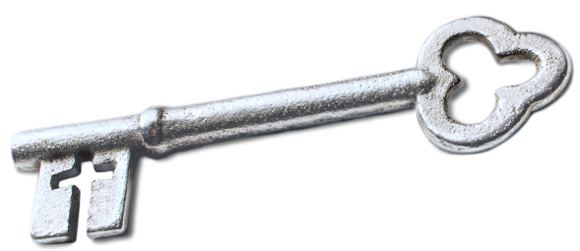
Sermon Notes
Identity in Christ
Luke 19:1-10 (John 1:11-12)
(Page 732 in the Pew Bible)

- Key Question
  - _________ am _________?

- Key Idea
  - I believe I am _____________ because of my ____________ as a child of God

- What Do I Believe?
  - I am free from _____________

  - My ___________ comes from my position in Christ, not my _____________

  - I live to __________ who I am in Christ, not to __________ who I am

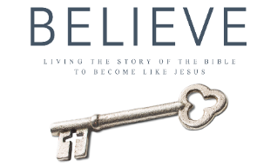
  - I can focus on __________ others up, not __________ them down
Each week of BELIEVE we ask you to read one chapter in preparation for the next Sunday. Please read Chapter 6 for Sunday March 25th.

