From BELIEVE, “God created everything, but the pinnacle of creation was the making of human beings-creatures crafted in the image of God. Humanity is special, and the Bible is the record of the love story between Creator and created, between God and humans. From the very beginning of time to the era of the modern-day church, God has loved and pursued His people in order to restore His image within and among them.”

Sermon Notes
Humanity
Luke 7:36-50 (John 3:16-17)
(Page 721 in the Pew Bible)

- Key Question
  - How does God _________ us?

- Key Idea
  - I believe all people are ________ by God and _______ Jesus Christ as their Savior

- What do I Believe?
  - I am “_________” and so is ________ else

  - I need to _______ people the way _______ sees them … in need of a ___________

  - One ___________ of my _________ for God is in the way I _________ people … as He _________ people.
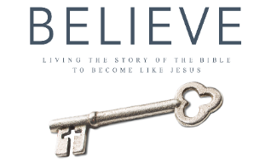
Each week of BELIEVE we ask you to read one chapter in preparation for the next Sunday. Please read Chapter 8 for Sunday April 22nd.

