Each Christmas our hearts and minds are reminded of the sleepy little village called Bethlehem. We rightly think of Bethlehem as the birthplace of our Lord and Savior, Jesus Christ. However, Bethlehem’s history is much deeper than that single night. In fact, the first mention of this sleepy village is all the way back in the book of Genesis in connection to the burial site of Jacob’s love, Rachel. Today, we turn to the story of Naomi and Ruth as we begin a journey to uncover the significant events in Bethlehem that paved the way for Jesus’ birth.

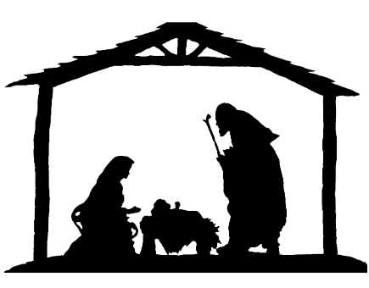
Sermon Notes
Take Me Back to Bethlehem
Hope in the Light
Ruth 1 (Micah 5:2)
(Page 182 in the Pew Bible)

Naomi and Ruth’s return to Bethlehem emphasizes …
- The _____________ of the return

- The _____________ of the return

- The _____________ of the return

- The _____________ of the return

In my moments of darkness, I can find similar light in the hope of Jesus …
- Hope because the ____________ of my sin is ___________

- Hope through two ______________

  - The sacrifice of _______________

  - The sacrifice I must make to ______________ Jesus

- Hope through the ____________ of Jesus’ ____________

- Hope through the _____________ of my ____________

Outlined structured from comments in Dr. James E. Smith’s commentary The Pentateuch

