Happy Mother’s Day! Mother’s Day is a special day we set aside to honor the woman we call mom. For many of us, today is a day to remember all the ways she has showed us her love through the years. However, for some of us, we don’t have the best relationships with our mothers. Some of us don’t have the best relationships with other family members. How do we cope? How do we respond? How do we find hope? Today, we begin a new series answering these questions when we find ourselves Behind Family Lines.

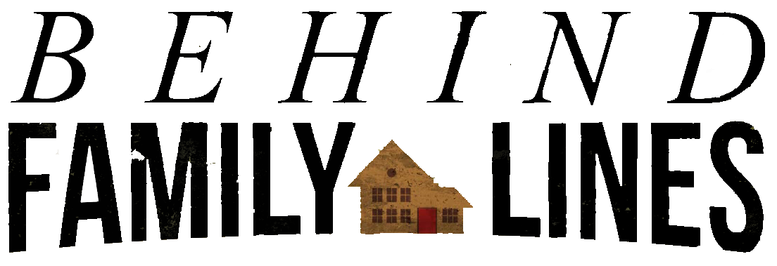

Sermon Notes
Hope Behind the Line
1 Samuel 1 (Proverbs 24:3-4) (Page 267 In the Pew Bible)

- Behind Family Lines – Even the best of us experience ____________ that are out of our ____________

- Behind Family Lines – We may have to work through ____________ we have ____________ into our homes

- Behind Family Lines – I must remember, when I am in __________, the __________ place to go is to God

- Behind Family Lines - Through my faithful ____________, God can provide __________

