From BELIEVE … “We simply cannot live without hope. As our key verse states, Christian hope is an anchor for our soul. It stabilizes us during difficult seasons because we know this is not how our story ends. It is rooted in our belief and trust in a personal God, his salvation and eternity. If we believe these truths in our hearts, then it will produce a hope that doesn’t disappoint.”

Sermon Notes
Hope
Psalm 42 (Hebrews 6:19-20)
(Page 391 in the Pew Bible)

Key Question
- How do I deal with the __________ and __________ of life?

Key Idea
- I can cope with the _________ of life because of the _________ I have in Jesus Christ

Who Am I Becoming?
- I am becoming a Christian who is __________ onto the __________ of my savior

- Hope is the Greek phrase __________
  - _________ means to _________

- Hope is the Hebrew word ___________
  - __________ is to __________, to be __________, to stay, and to __________

- Jesus is my source of __________-__________ hope during hardship and struggle.

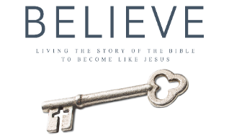
Each week of BELIEVE we ask that you read one chapter in preparation for the next Sunday. Please read Chapter 26 for next Sunday September 23rd.

