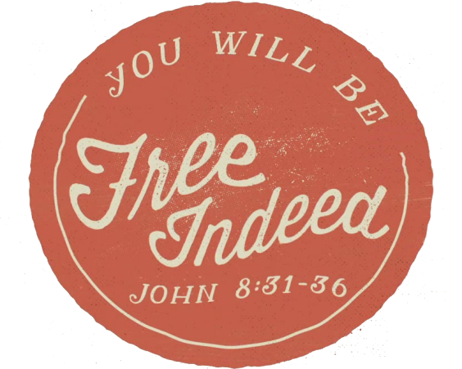
Tomorrow, July 4th, we celebrate our nation’s independence from British rule. With that independence came a freedom that no citizen of any other nation in this history of the world has ever held. Our American freedom has gone a long way to shaping our concept and understanding of what freedom is. However, Jesus has a different idea concerning freedom. When we compare Jesus’ freedom to our American freedom, the two simply cannot compare. Today, with freedom on our minds, we will look at and try to understand the freedom we have in Christ as Children of God!

Sermon Notes
Free Indeed
John 8:31-36 (Romans 8:1-2)
(Page 746 in the Pew Bible)

- Jesus offers a freedom we have little ________ for

- Jesus offers a freedom that breaks the _________ of our ________

- Jesus offers our ____________ of ______________

- Jesus offers …

  - Freedom from sins ___________

  - Freedom from sins ___________

  - Freedom from sins ___________

  - Freedom from sins ___________

  - Freedom from sins ___________

- Jesus’ offer makes us ________ _________

