In 1957, English singer Laurie London, made popular the American spiritual, He’s Got the Whole World in His Hands. Since that time, this song has been recorded by many gospel singers, and sung by thousands of Sunday School classes and church camp groups. While it is a popular song we teach our children, how often do we think about the theological depth these lyrics communicate? This morning, we will unpack deeper what it means for God to have the whole world in His hands.

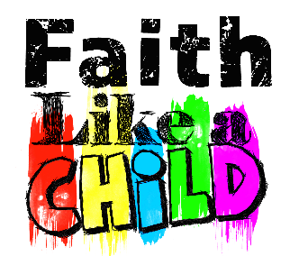
Sermon Notes
He’s Got the Whole World
Jeremiah 18 (Colossians 1:15-17)
(Page 773 in the Pew Bible)

- Jeremiah watched and learned that the potter had _____________ _____________ over the clay
  - A potter is able to use their hands to _________ or ____________ any imperfections

- God is __________ than any ____________
  - In His hands is the ____________ control of the ____________
  - God can __________ __________ any nation
  - God can __________ __________ any nation

- When I am ____________ …
  - … God still __________ for me
  - … God’s _________ drives Him to be ___________ with me

- When my life is ____________, I can find ___________ knowing …
  - … God still __________ for me
  - … God has me in His _________, and can _________ me into something _____________
  - … God is my heavenly __________, and I can place my ___________ in Him

