  - From BELIEVE … “There is life after death. Eternal life with God. God wants to restore His original vision of life with us in the garden. The only way back into the garden is through faith in Jesus Christ. Those who embrace Christ in this life are reconciled to God and become a new creation with a new identity.” Today, we get a small taste of what’s instore for those of us who have trusted our eternity to Jesus.

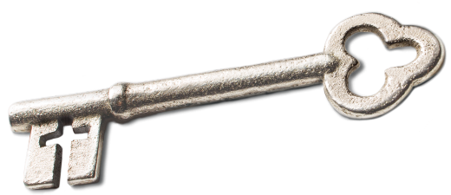
Sermon Notes
Eternity
2 Kings 2 (John 14:1-2)
(Page 252 in the Pew Bible)
- Key Question
  - What happens _________?

- Key Idea
  - I believe there is a __________ and a __________ and that Jesus will return to __________ all people and to _______________ His eternal kingdom

- What do I Believe?
  - I am created to be ___________

  - I have a __________ eternal home waiting for me if I am __________

  - In Christ, all I have to wait for is my ______________

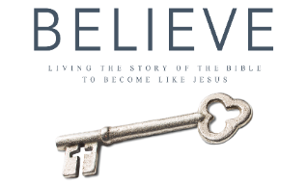
Next Sunday is Mother’s Day and we will be taking a one week break to honor our mothers. This is a good chance to catch up on your BELIEVE reading.

