Nearly 2,000 years ago Jesus was sent to cross to die for the sins of mankind. Three days later, He conquered death by resurrecting from the grave. But not everyone has readily believed that. Even one of His own disciples had his own doubt. Thomas needed to see the resurrected Jesus for himself. He needed to see and touch the wounds of Jesus. He did see, and his proclamation of his faith is one we can echo today.
Each week of BELIEVE we will ask you to read one chapter in preparation for the next Sunday. Please read Chapter 6 for Sunday April 6th.

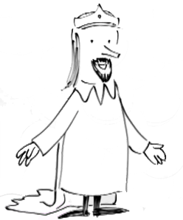
Sermon Notes
Jesus’ Resurrection is No April Fool’s!
John 20:24-29 (Matthew 28:5-7)
(Page 757 in the Pew Bible)

- Thomas needed __________ evidence that Jesus had _________
  - Thomas was neither ________ nor ________ of a resurrection

  - Thomas knew ________ people don’t come back to _______

  - Thomas ________ to see and touch the ________ of Jesus

- Thomas was ________ through the same ________ of ________ I must take
  - Jesus understands our need for _________

  - Jesus ________ Thomas’ validation of the evidence

- Thomas quickly ________ and _________ the incarnation of God
  - Incarnation = God in the ________, not a ________ or a ________

  - “My Lord and my God!” had crossed a _________ and yet ________ line … Thomas had ________ that Jesus is the Christ

- Thomas’ ________ with the resurrected Jesus is __________ for me
  - I am ________ because I believe without ________

