At our fingertips we have access to unlimited amounts of information. We can browse the web, and research any topic we want to learn more about. This is a great time to be alive. However, with so much information out there, how do we determine what is true and what is not? This is especially important when we talk about our faith. There is so much information and interpretation about and of the Bible, how do we know what’s true? Today, we will emphasize the importance of what it means to stand on truth.

Psalm 145:1-3

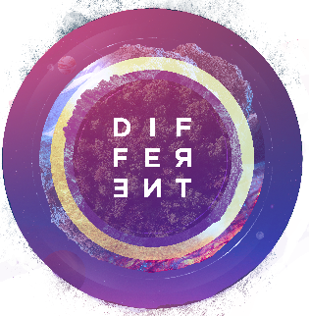
Sermon Notes
Different Because I Stand on Truth
2 Peter 2
(Page 1226 in the Pew Bible)

- I am different because I will not be _________ _________

  - God will punish those who follow _____________ sinful __________

  - God will __________ and __________ those who remain faithful to Him

- I am different because I __________ about what is being _________

  - False teachers love to __________ on those __________ to the faith

  - We must __________ __________ those who are __________ to the faith

- I am different because I __________ look to the __________ of Jesus’ work on the cross

