From BELIEVE … “The key idea highlighted in Chapter 4 – the Bible is the Word of God and has the right to command our beliefs and actions-is a key belief for every Christian. Over many years God superintended the process to bring us His Word, His revelation. It is through the Bible that we learn how to think, act, and become like Jesus. The ancient stories and words are “alive and active” and totally capable of leading us along the right path. But like a trustworthy map, we must use it for it be effective. Making Bible study a key practice can help us get to where God wants to take us.”

Sermon Notes
Bible Study
Mark 4:1-20 (Hebrews 4:12)
(Page 701 in the Pew Bible)

Key Question
- _________ do I study God’s Word?

Key Idea
- I study the Bible to _________ God and His _________ and to find ____________ for my daily life

What Should I Do?
- The soil in Jesus’ parable represents four ______________ of the human __________

  - The hard path … an ______________ heart

  - The rocky soil … a __________ heart

  - The weedy soil … a __________ heart

  - The good soil … a _____________heart

- If Bible study is going to help me _________ God, I need to know what _________ of ________ I am

- We have good news … I can _________ my soil ______________!

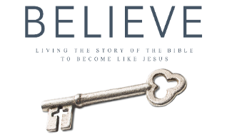
Each week of BELIEVE we ask you to read one chapter in preparation for the next Sunday. Please read Chapter 14 for Sunday June 10th.

