Happy Mother’s Day! Thank you to all the moms who have sacrificially given your love, your time, and your energy to mold and shape us into the people we are. In many ways moms are the backbone of our family. While we could go on and on about how special our moms are, we hope a simple thank you speaks volumes.

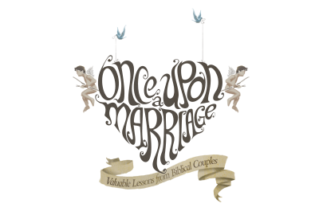

Sermon Notes
Once Upon a Marriage
Abraham and Sarah
Genesis 12:1-7 (Psalm 8:1-2)
(Page 8 in the Pew Bible)

- In faithless seasons … we fall victim to _____________ - Genesis 12:10-13

- In faithless seasons … we get ___________ of God – Genesis 16:1-4

- In faithless seasons … we don’t believe _____________ will do it for ____________ - Genesis 17:15-19

Sermon Series and Notes developed from LifeChurch.TV

