Happy Mother’s Day! We just want to say thank you to all the moms who have done so much for all of us. You often sacrificed your wants and desires to make sure all our needs were met. Not only did you do things for us, but you also prayed for us. You made request to God on our behalf. Our response is honoring those requests daily. Today, we will examine some of the things moms pray for and examine how we are doing at honoring those requests.

Sermon Notes
A Mother’s Request
Matthew 20:20-23 (Psalm 18:1-3)
(Page 690 in the Pew Bible)

- Salome requested three things from Jesus for her sons …

  - Request #1 … She wanted her sons to be a part of Jesus’ ______________

  - Request #2 … She wanted her sons to be __________ in the __________ work

  - Request #3 … She wanted __________ __________ for her sons

- How am I doing at ____________ my ____________ desires?

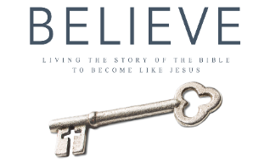
Sermon outline developed from Melvin Newland’s sermon A Mother’s Love
Each week of BELIEVE we ask you to read one chapter in preparation for the next Sunday. Please read Chapter 11 for Sunday May 20th.

