Too many of us are living in a prison of financial debt and stress. The good news is we can learn how to get out of financial bondage. Today we begin our new series, Strapped, as we get smart with our money and begin learning some biblical principles to free ourselves as we seek to be good stewards of God’s rich blessings.

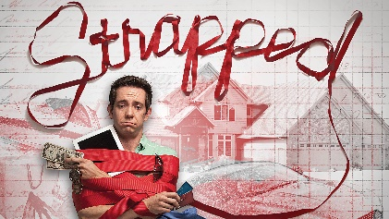
Sermon Notes
A Godly Perspective on Money
Mathew 6:19-24 (Psalm 81:1-2)
(Page 679 in the Pew Bible)

- Wealth has the __________ to __________ me from God

  - Wealth can __________ my ________

  - Wealth can __________ me to __________ it

- When I see my wealth as a tool to __________, I am living in the __________

- I must choose which I am going to ________, _________ or __________

  - My choice _______________ my true __________

